+

SQL Training
Course-End Project Problem Statement



Course-End Project: Air Cargo Analysis

Problem Statement Scenario:

Air Cargo is an aviation company that provides air transportation services for
passengers and freight. Air Cargo uses its aircraft to provide different services with
the help of partnerships or alliances with other airlines. The company wants to
prepare reports on regular passengers, busiest routes, ticket sales details, and
other scenarios to improve the ease of travel and booking for customers.

Project Objective:

You, as a DBA expert, need to focus on identifying the regular customers to provide offers, analyze the busiest route which helps to increase the number of aircraft required and prepare an analysis to determine the ticket sales details. This will ensure that the company improves its operability and becomes more customer-centric and a favorable choice for air travel.

Note: You must download the dataset from the course resource section in the LMS and create the tables to perform the above objective.

Dataset description:

Customer: Contains the information of customers
- customer_id – ID of the customer
- first_name – First name of the customer
- last_name – Last name of the customer
- date_of_birth – Date of birth of the customer
- gender – Gender of the customer

passengers_on_flights: Contains information about the travel details

- aircraft_id – ID of each aircraft in a brand
- route_id – Route ID of from and to location
- customer_id – ID of the customer
- depart – Departure place from the airport
- arrival – Arrival place in the airport
- seat_num – Unique seat number for each passenger
- class_id – ID of travel class
- travel_date – Travel date of each passenger
- flight_num – Specific flight number for each route

ticket_details: Contains information about the ticket details
- p_date – Ticket purchase date
- customer_id – ID of the customer
- aircraft_id – ID of each aircraft in a brand
- class_id – ID of travel class
- no_of_tickets – Number of tickets purchased
- a_code – Code of each airport
- price_per_ticket – Price of a ticket
- brand – Aviation service provider for each aircraft

routes: Contains information about the route details

- Route_id – Route ID of from and to location
- Flight_num – Specific fight number for each route
- Origin_airport – Departure location
- Destination_airport – Arrival location
- Aircraft_id – ID of each aircraft in a brand
- Distance_miles – Distance between departure and arrival location

Following operations should be performed:

- Create an ER diagram for the given airlines database.
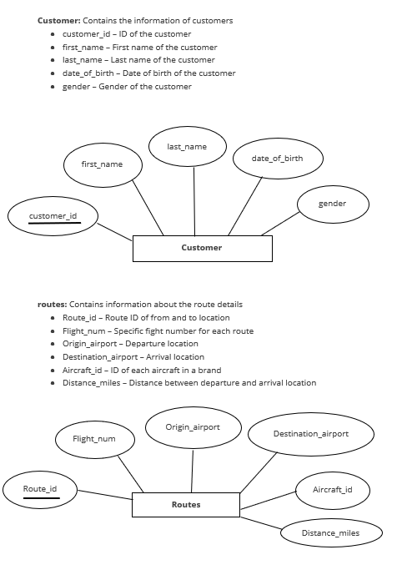

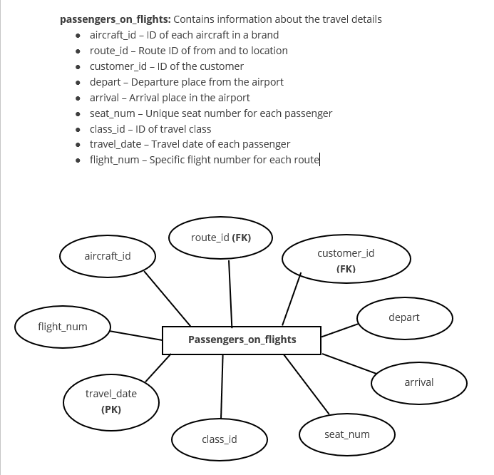

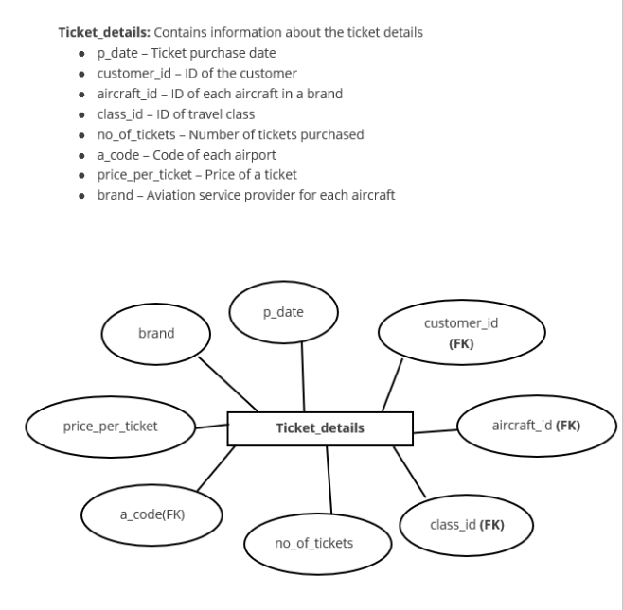

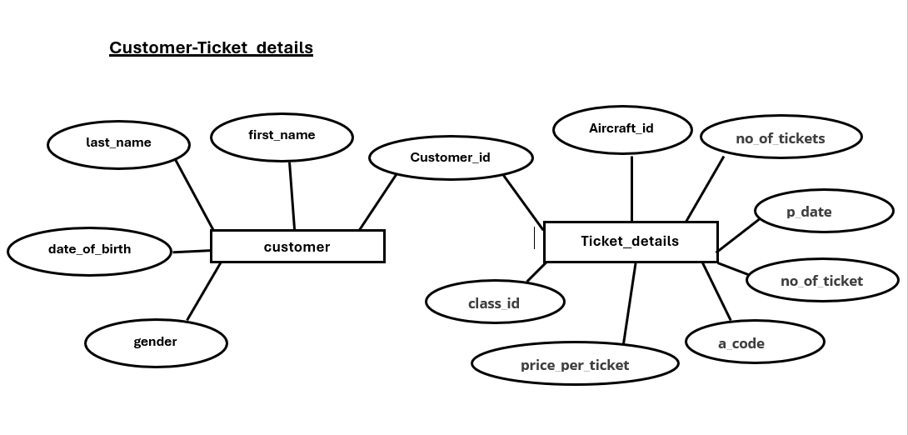
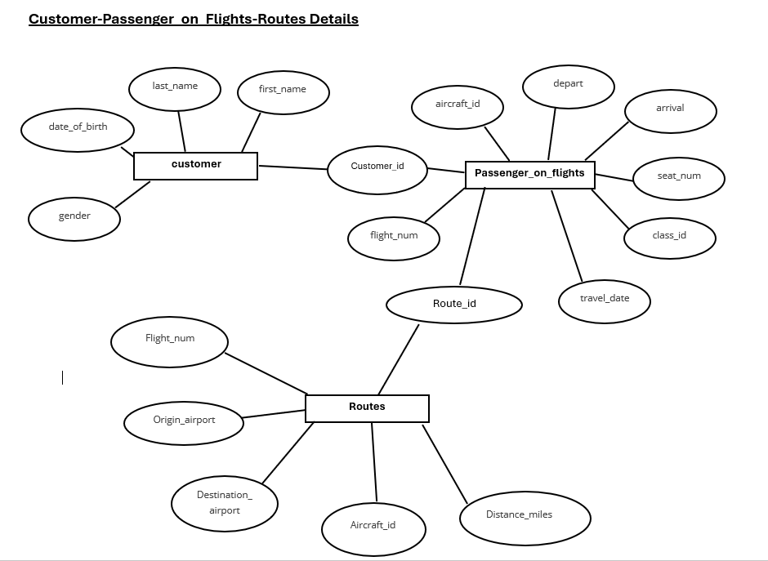

- Write a query to create a route_details table using suitable data types for the fields, such as route_id, flight_num, origin_airport, destination_airport, aircraft_id, and distance_miles. Implement the check constraint for the flight number and unique constraint for the route_id fields. Also, make sure that the distance miles field is greater than 0.

create table Route_details (
route_id int primary key,
flight_num int check(flight_num>0),
origin_airport varchar(20),
destination_airport varchar(20),
aircraft_id varchar(10),
distance_miles int check(distance_miles>0));

- Write a query to display all the passengers (customers) who have travelled in routes 01 to 25. Take data from the passengers_on_flights table.

select c.first_name,c.last_name,
p.route_id,p.travel_date,p.flight_num,
r.origin_airport, r.destination_airport,r.aircraft_id
From customer as c inner join passengers_on_flights as p
ON c.customer_id=p.customer_id
inner join routes as r
ON p.route_id=r.route_id
where p.route_id between 1 and 25
order by r.route_id;

- Write a query to identify the number of passengers and total revenue in business class from the ticket_details table.

select class_id, sum(no_of_tickets) As No_Of_Passengers,
sum(no_of_tickets*Price_per_ticket) As Total_Revenue from
ticket_details
where Class_id='Bussiness';

- Write a query to display the full name of the customer by extracting the first name and last name from the customer table.

select concat(first_name,' ',last_name) As Full_Name from customer;

- Write a query to extract the customers who have registered and booked a ticket. Use data from the customer and ticket_details tables.

select distinct c.customer_id, concat(c.first_name,' ',c.last_name) As
Full_Name,t.aircraft_id,t.class_id
From customer As c inner join ticket_details As T
on c.Customer_id=t.customer_id;

- Write a query to identify the customer’s first name and last name based on their customer ID and brand (Emirates) from the ticket_details table.

select distinct c.customer_id, concat(c.first_name,' ',c.last_name) As
Full_Name,t.brand
From customer As c inner join ticket_details As T
on c.Customer_id=t.customer_id
where t.brand='Emirates';

- Write a query to identify the customers who have travelled by Economy Plus class using Group By and Having clause on the passengers_on_flights table.

select c.first_name,c.last_name,p.class_id
from customer as c inner join passengers_on_flights as p
On c.customer_id=p.customer_id
where class_id=(
select class_id from passengers_on_flights
group by class_id having max(class_id)='Economy Plus');

- Write a query to identify whether the revenue has crossed 10000 using the IF clause on the ticket_details table.
select if(sum(no_of_tickets*price_per_ticket)>10000,'crossed
10000','Not crossed') As Revenue_status from ticket_details;

- Write a query to create and grant access to a new user to perform operations on a database.

create user 'Simplilearn'@'localhost' identified by 'Password123';
Grant all privileges on air_cargodb. * To 'Simplilearn'@'localhost';
Flush privileges;

- Write a query to find the maximum ticket price for each class using window functions on the ticket_details table.

select class_id,price_per_ticket,max(price_per_ticket)
over(PARTITION BY class_id)As max_ticket_price
From ticket_details;

- Write a query to extract the passengers whose route ID is 4 by improving the speed and performance of the passengers_on_flights table.

create index idx_route_id
ON passengers_on_flights(route_id);

select*from passengers_on_flights
where route_id=4;

- For the route ID 4, write a query to view the execution plan of the passengers_on_flights table.

Explain
select*from passengers_on_flights
where route_id=4;

- Write a query to calculate the total price of all tickets booked by a customer across different aircraft IDs using rollup function.

select
customer_id,
aircraft_id,
sum(no_of_tickets*price_per_ticket) As total_amount
from ticket_details
group by customer_id,aircraft_id WITH ROLLUP;

- Write a query to create a view with only business class customers along with the brand of airlines.

CREATE VIEW bussiness_class_customers AS
SELECT p.customer_id,
p.aircraft_id,
p.class_id,
t.brand
FROM passengers_on_flights AS p
JOIN ticket_details AS t
ON p.customer_id=t.customer_id
AND p.aircraft_id = t.aircraft_id
where p.class_id = 'Bussiness';

- Write a query to create a stored procedure to get the details of all passengers flying between a range of routes defined in run time. Also, return an error message if the table doesn't exist.

delimiter $$
CREATE PROCEDURE
get_passengers_by_route_range(
IN start_route INT,
In end_route INT
)
BEGIN

If EXISTS(
SELECT 1 from information_schema.tables
WHERE table_schema=DATABASE()
AND tabLe_name ='passengers_om_flights'
) THEN
SELECT* FROM passengers_on_flights
WHERE route_id BETWEEN start_route AND end_route;
ELSE
SELECT 'Error:passengers_on_flights table does not exists' AS
Messege;
END IF;
END $$
DELIMITER ;

- Write a query to create a stored procedure that extracts all the details from the routes table where the travelled distance is more than 2000 miles.

DELIMITER $$
CREATE PROCEDURE get_long_distance_routes()
begin
select * from routes
where distance_miles>2000;
end $$
DELIMITER ;

- Write a query to create a stored procedure that groups the distance travelled by each flight into three categories. The categories are, short distance travel (SDT) for >=0 AND <= 2000 miles, intermediate distance travel (IDT) for >2000 AND <=6500, and long-distance travel (LDT) for >6500.

CREATE PROCEDURE get_distance_category()
begin
select
distance_miles,
CASE
WHEN distance_miles BETWEEN 0 AND 2000 THEN 'SDT'
WHEN distance_miles BETWEEN 2001 AND 6500 THEN 'IDT'
ELSE 'LDT'
END AS travel_category
FROM routes;
END $$
DELIMITER ;

- Write a query to extract ticket purchase date, customer ID, class ID and specify if the complimentary services are provided for the specific class using a stored function in stored procedure on the ticket_details table.
Condition:
- If the class is Business and Economy Plus, then complimentary services are given as Yes, else it is No

DELIMITER $$
CREATE PROCEDURE get_ticket_details()
BEGIN
SELECT
p_date,
customer_id,
class_id,
check_complimentary(class_id)AS
complimentary_service
FROM ticket_details;
END $$
DELIMITER ;

- Write a query to extract the first record of the customer whose last name ends with Scott using a cursor from the customer table.

DELIMITER $$
CREATE PROCEDURE get_first_scott()
BEGIN
DECLARE c_id INT;
DECLARE f_name VARCHAR(50);
DECLARE l_name VARCHAR(50);

DECLARE cur CURSOR FOR
SELECT customer_id, first_name,last_name
FROM customer
WHERE last_name LIKE'%Scott';

OPEN cur;
FETCH cur INTO c_id,f_name,l_name;
SELECT c_id AS customer_id,
f_name AS first_name,
l_name AS last_name;
CLOSE cur;
END $$
DELIMITER ;

